

SCHOOL OF COMPUTER SCIENCE ENGINEERING AND INFORMATION SYSTEMS
ASSESSMENT-2

NAME : HEMAVARSHINI.M
REGNO:24MIS0416
FACULTY NAME : DR PRASANNA.M
COURSE CODE: ISWE305P
COURSE NAME : SOFTWARE TESTING-LAB
LAB SLOT: L47+L48

Question 1:
A Nuclear Power Plant Reactor Monitoring System continuously supervises critical reactor parameters to ensure safe plant operation and prevent catastrophic failures. The system monitors the following variables:
• Reactor Core Temperature: 200°C to 1200°C
• Coolant Level: 20% to 100%
• Radiation Level: 0 mSv to 500 mSv
• Reactor Pressure: 100 kPa to 1000 kPa
I)The system automatically triggers alarms, activates emergency cooling mechanisms, or initiates reactor shutdown procedures whenever unsafe operating conditions are detected.
Tasks to be Performed:
1. Identify all boundary values associated with each monitored parameter.
2. Generate Boundary Value Analysis (BVA) test cases for the reactor monitoring application.
3. Generate Robust Testing test cases by considering invalid values below and above the permissible limits.
4. Identify combinations of parameter values that could result in reactor malfunction, radiation leakage, or complete mission failure, and specify the corresponding emergency actions that should be initiated by the system

Problem Statement
A Nuclear Power Plant Reactor Monitoring System is designed to continuously monitor critical operating parameters to ensure reactor safety. The system checks Reactor Core Temperature, Coolant Level, Radiation Level, and Reactor Pressure. Depending on the values entered, the system displays whether the reactor is operating normally or performs appropriate safety actions such as issuing warnings, activating emergency cooling, or initiating reactor shutdown when critical conditions are detected.

Algorithm
- Start the program.
- Read the reactor core temperature.
- Read the coolant level.
- Read the radiation level.
- Read the reactor pressure.
- Verify that all inputs are within the specified operating ranges.
- If any value is outside the valid range, display "Invalid Input".
- Otherwise:
  - If all four parameters reach critical levels, display "Reactor Shutdown Initiated".
  - Else if temperature or pressure reaches the maximum safe limit, display "Emergency Cooling Activated".
  - Else if radiation reaches the warning level, display "Radiation Warning".
  - Otherwise display "Reactor Status: Safe".
- End the program.
CODE:
import java.util.Scanner;

public class ReactorMonitoringSystem {

public static void main(String[] args) {

Scanner input = new Scanner(System.in);

System.out.print("Enter Reactor Temperature (°C): ");
int temp = input.nextInt();

System.out.print("Enter Coolant Level (%): ");
int coolant = input.nextInt();

System.out.print("Enter Radiation Level (mSv): ");
int radiation = input.nextInt();

System.out.print("Enter Reactor Pressure (kPa): ");
int pressure = input.nextInt();

if (temp < 200 || temp > 1200 ||
coolant < 20 || coolant > 100 ||
radiation < 0 || radiation > 500 ||
pressure < 100 || pressure > 1000) {

System.out.println("Invalid Input");

} else {

if (temp == 1200 && coolant == 20 &&
radiation == 500 && pressure == 1000) {

System.out.println("Reactor Shutdown Initiated");

} else if (temp >= 1150 || pressure >= 950) {

System.out.println("Emergency Cooling Activated");

} else if (radiation >= 450) {

System.out.println("Radiation Warning");

} else {

System.out.println("Reactor Status : Safe");
}
}

input.close();
}
}
OUTPUT:
Positive output:
1)
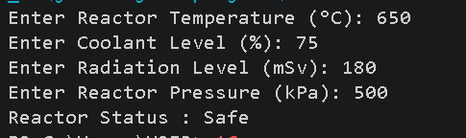
2)
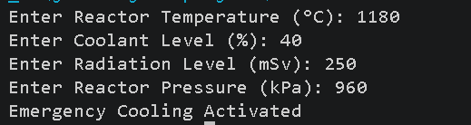
Negative output:
1)
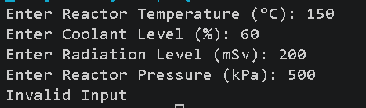
2)
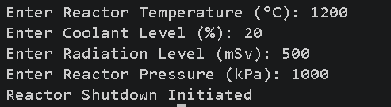
DESIGN A TEST CASE TABLES:
Table 1: Boundary values
Parameter | Minimum | Minimum +1 | Nominal | Maximum -1 | Maximum
Reactor Core Temperature (°C) | 200 | 201 | 750 | 1199 | 1200
Coolant Level (%) | 20 | 21 | 65 | 99 | 100
Radiation Level (mSv) | 0 | 1 | 300 | 499 | 500
Reactor Pressure (kPa) | 100 | 101 | 600 | 999 | 1000

Table 2: Boundary Value Analysis (BVA) Test Cases
TC ID | Temperature | Coolant | Radiation | Pressure | Expected Result
BVA-01 | 200 | 65 | 300 | 600 | Valid
BVA-02 | 201 | 65 | 300 | 600 | Valid
BVA-03 | 1199 | 65 | 300 | 600 | Valid
BVA-04 | 1200 | 65 | 300 | 600 | Valid
BVA-05 | 750 | 20 | 300 | 600 | Valid
BVA-06 | 750 | 100 | 300 | 600 | Valid
BVA-07 | 750 | 65 | 0 | 600 | Valid
BVA-08 | 750 | 65 | 500 | 600 | Valid
BVA-09 | 750 | 65 | 300 | 100 | Valid
BVA-10 | 750 | 65 | 300 | 1000 | Valid

Table 3: Robust Testing Test Cases:
TC ID | Temperature | Coolant | Radiation | Pressure | Expected Result
RT-01 | 199 | 65 | 300 | 600 | Invalid
RT-02 | 1201 | 65 | 300 | 600 | Invalid
RT-03 | 750 | 19 | 300 | 600 | Invalid
RT-04 | 750 | 101 | 300 | 600 | Invalid
RT-05 | 750 | 65 | -1 | 600 | Invalid
RT-06 | 750 | 65 | 501 | 600 | Invalid
RT-07 | 750 | 65 | 300 | 99 | Invalid
RT-08 | 750 | 65 | 300 | 1001 | Invalid

Table 4: Reactor Failure / Emergency Condition Combinations
Case ID | Temperature | Coolant | Radiation | Pressure | System Status | Emergency Action
EC-01 | >1200°C | Normal | Normal | Normal | High Temperature | Activate Emergency Cooling
EC-02 | Normal | <20% | >500 mSv | Normal | Radiation Risk | Trigger Radiation Alarm
EC-03 | >1200°C | <20% | Normal | >1000 kPa | Critical Condition | Emergency Cooling + Alarm
EC-04 | >1200°C | <20% | >500 mSv | >1000 kPa | Reactor Failure | Immediate Reactor Shutdown

Question 2:
A Smart Elevator Monitoring System continuously monitors the operating conditions of an
elevator in a commercial building. The system checks the following parameters:
• Number of Passengers: 0 to 15 persons
• Load Weight: 0 kg to 1000 kg
• Elevator Speed: 0 m/s to 5 m/s
• Cabin Temperature: 15°C to 40°C
Tasks to be Performed:
1. Identify all boundary values for each input parameter.
2. Generate Boundary Value Analysis (BVA) test cases.
3. Generate Robust Testing test cases by considering values just below and above the valid
ranges.
4. Determine which combinations of parameter values may lead to system failure or unsafe
conditions, such as:
o Number of passengers exceeding 15.
o Load weight greater than 1000 kg.
o Excessive elevator speed combined with overload conditions.
o Extremely high cabin temperature and overload occurring simultaneously.
Implement the above application and analyze it using Boundary Value Analysis (BVA) and Robust Testing techniques.

Problem Statement
A Smart Elevator Monitoring System continuously monitors the operating conditions of an elevator in a commercial building. The system checks the Number of Passengers, Load Weight, Elevator Speed, and Cabin Temperature. If any parameter exceeds its permissible limit, the system generates warning messages and may stop the elevator to ensure passenger safety.

Algorithm
- Start the program.
- Read the number of passengers.
- Read the load weight.
- Read the elevator speed.
- Read the cabin temperature.
- Check whether all values are within the valid range.
- If any value is outside the range, display "Invalid Input".
- If passengers exceed 15 or load exceeds 1000 kg, display "Overload Detected".
- If speed exceeds the safe limit along with overload, stop the elevator.
- If cabin temperature is very high and overload exists, display an emergency warning.
- Otherwise, display "Elevator Operating Normally".
- Stop.
Code:
import java.util.Scanner;

public class SmartElevator {

public static void main(String[] args) {

Scanner sc = new Scanner(System.in);

System.out.print("Enter Number of Passengers: ");
int passengers = sc.nextInt();

System.out.print("Enter Load Weight (kg): ");
int weight = sc.nextInt();

System.out.print("Enter Elevator Speed (m/s): ");
double speed = sc.nextDouble();

System.out.print("Enter Cabin Temperature (°C): ");
int temp = sc.nextInt();

if (passengers < 0 || passengers > 15 ||
weight < 0 || weight > 1000 ||
speed < 0 || speed > 5 ||
temp < 15 || temp > 40) {

System.out.println("Invalid Input");

} else if (passengers == 15 && weight >= 1000 && speed >= 5) {

System.out.println("Emergency Stop Activated");

} else if (passengers > 12 || weight > 900) {

System.out.println("Warning : Elevator Near Capacity");

} else if (temp >= 38) {

System.out.println("Warning : High Cabin Temperature");

} else {

System.out.println("Elevator Operating Normally");
}

sc.close();
}
}
Positive output:
1)
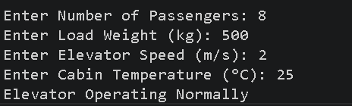
2)
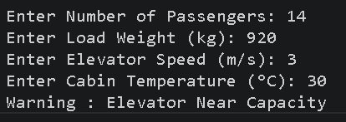
Negative output:
1)
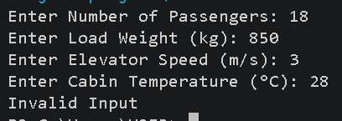
2)
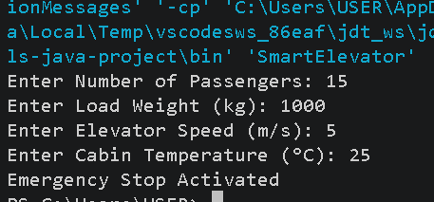
Design a testcase table:
Table 1: Boundary Values
Parameter | Minimum | Minimum+1 | Nominal | Maximum-1 | Maximum
Passengers | 0 | 1 | 8 | 14 | 15
Load Weight (kg) | 0 | 1 | 500 | 999 | 1000
Elevator Speed (m/s) | 0 | 0.1 | 2.5 | 4.9 | 5
Cabin Temperature (°C) | 15 | 16 | 28 | 39 | 40

Table 2: Boundary Value Analysis (BVA)
TC ID | Passengers | Weight | Speed | Temperature | Expected Result
BVA-01 | 0 | 500 | 2.5 | 28 | Valid
BVA-02 | 1 | 500 | 2.5 | 28 | Valid
BVA-03 | 14 | 500 | 2.5 | 28 | Valid
BVA-04 | 15 | 500 | 2.5 | 28 | Valid
BVA-05 | 8 | 0 | 2.5 | 28 | Valid
BVA-06 | 8 | 1000 | 2.5 | 28 | Valid
BVA-07 | 8 | 500 | 0 | 28 | Valid
BVA-08 | 8 | 500 | 5 | 28 | Valid
BVA-09 | 8 | 500 | 2.5 | 15 | Valid
BVA-10 | 8 | 500 | 2.5 | 40 | Valid
Table 3: Robust Testing
 | Passengers | Weight | Speed | Temperature | Expected Result
RT-01 | -1 | 500 | 2.5 | 28 | Invalid
RT-02 | 16 | 500 | 2.5 | 28 | Invalid
RT-03 | 8 | -5 | 2.5 | 28 | Invalid
RT-04 | 8 | 1001 | 2.5 | 28 | Invalid
RT-05 | 8 | 500 | -0.5 | 28 | Invalid
RT-06 | 8 | 500 | 5.5 | 28 | Invalid
RT-07 | 8 | 500 | 2.5 | 14 | Invalid
RT-08 | 8 | 500 | 2.5 | 41 | Invalid

Table 4: Unsafe Condition / System Failure Combinations
Case ID | Passengers | Load (kg) | Speed (m/s) | Temperature (°C) | System Status | Action
SF-01 | 16 | 900 | 3.0 | 28 | Passenger Limit Exceeded | Prevent Elevator Start
SF-02 | 10 | 1050 | 2.5 | 30 | Overloaded | Activate Overload Alarm
SF-03 | 16 | 1100 | 5.2 | 32 | Critical Overload & Overspeed | Stop Elevator Immediately
SF-04 | 14 | 1000 | 4.8 | 41 | High Temperature | Trigger Cooling & Warning
SF-05 | 16 | 1100 | 5.2 | 42 | Critical Unsafe Condition | Emergency Shutdown

Question 3:
An Online Hotel Reservation Management System is developed to automate the booking process for customers reserving hotel rooms through a web-based platform. The system evaluates each booking request based on several business conditions, including room availability, payment status, customer membership category, booking amount, and availability of complimentary services. For every reservation request, the system checks whether the requested room is available, whether the payment transaction has been completed successfully, whether the customer is a loyalty member, whether the total booking amount exceeds ₹20,000, and whether airport pickup service is available. Based on the evaluation of these conditions, the system performs one or more of the following actions:
1. Confirm Reservation – The reservation is confirmed only if the room is available and payment has been successfully completed.
2. Provide Complimentary Benefits – Complimentary services such as free breakfast or room upgrades are provided if the customer is a loyalty member or if the booking amount exceeds ₹20,000.
3. Enable Airport Pickup Service – Airport pickup is enabled if the service is available and the reservation has been confirmed.
4. Put Reservation on Hold – The reservation is temporarily placed on hold if the room is available but payment verification is pending, allowing the customer to complete the payment within a specified time.
5. Cancel Reservation – The reservation is cancelled if:
o The requested room is unavailable.
o Payment is permanently declined.
o The customer fails to complete payment within the permitted time.
Tasks to be Performed:
1. Identify all possible combinations of the input conditions and construct a
comprehensive decision table.
2. Based on the decision table, generate all relevant test cases.
3. Implement the application and verify that all actions conform to the defined
business rules.
Problem Statement
An Online Hotel Reservation Management System automates hotel room bookings through a web-based application. The system evaluates each reservation request based on room availability, payment status, customer loyalty membership, booking amount, and airport pickup availability. According to these conditions, the system confirms the reservation, provides complimentary benefits, enables airport pickup, places the reservation on hold, or cancels the booking.

Algorithm
- Start the program.
- Accept room availability.
- Accept payment status (Success/Pending/Failed).
- Accept customer loyalty membership status.
- Accept booking amount.
- Accept airport pickup availability.
- If the room is unavailable, cancel the reservation.
- Else if payment is pending, place the reservation on hold.
- Else if payment has failed, cancel the reservation.
- Otherwise, confirm the reservation.
- If the customer is a loyalty member or booking amount exceeds ₹20,000, provide complimentary benefits.
- If airport pickup is available and the reservation is confirmed, enable airport pickup.
- Display all applicable actions.
- Stop.
Code:
import java.util.Scanner;

public class HotelReservationSystem {

public static void main(String[] args) {

Scanner sc = new Scanner(System.in);

System.out.print("Room Available (true/false): ");
boolean roomAvailable = sc.nextBoolean();

System.out.print("Payment Status (Success/Pending/Failed): ");
String payment = sc.next();

System.out.print("Loyalty Member (true/false): ");
boolean member = sc.nextBoolean();

System.out.print("Booking Amount: ");
double amount = sc.nextDouble();

System.out.print("Airport Pickup Available (true/false): ");
boolean pickup = sc.nextBoolean();

if (!roomAvailable) {
System.out.println("Reservation Cancelled");
}
else if (payment.equalsIgnoreCase("Pending")) {
System.out.println("Reservation On Hold");
}
else if (payment.equalsIgnoreCase("Failed")) {
System.out.println("Reservation Cancelled");
}
else {

System.out.println("Reservation Confirmed");

if (member || amount > 20000) {
System.out.println("Complimentary Benefits Granted");
}

if (pickup) {
System.out.println("Airport Pickup Enabled");
}
}

sc.close();
}
}
Positive Output:
1)
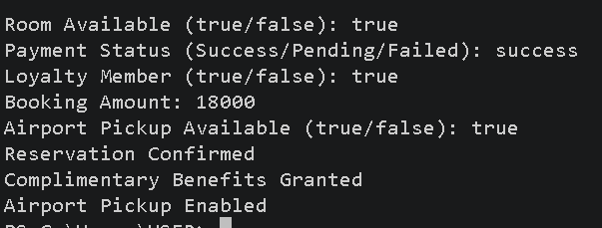
2)
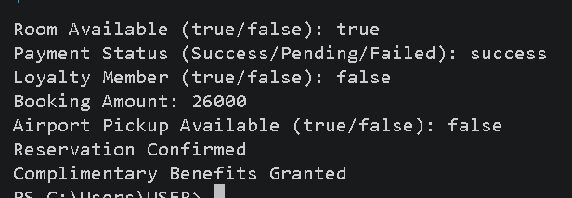
Negative output:
1)
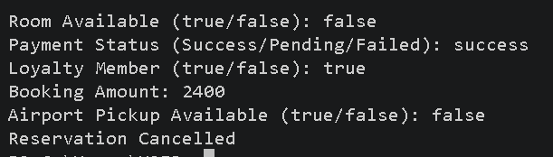
2)
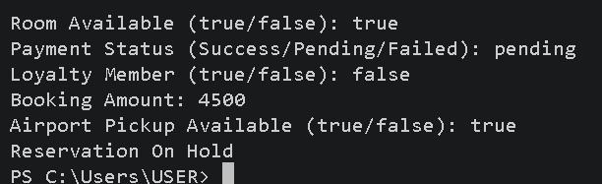
Design a testcase table:
Table 1:Decision Table
Conditions / Actions | Rule 1 | Rule 2 | Rule 3 | Rule 4 | Rule 5 | Rule 6
Room Available | Y | Y | Y | N | Y | Y
Payment Success | Y | N | N | - | Y | Y
Payment Pending | N | Y | N | - | N | N
Payment Failed | N | N | Y | - | N | N
Loyalty Member | Y | Y | N | N | N | Y
Booking Amount > ₹20,000 | N | N | Y | N | Y | N
Airport Pickup Available | Y | Y | N | N | Y | N
Confirm Reservation | ✔ | ✖ | ✖ | ✖ | ✔ | ✔
Complimentary Benefits | ✔ | ✖ | ✖ | ✖ | ✔ | ✔
Airport Pickup | ✔ | ✖ | ✖ | ✖ | ✔ | ✖
Reservation On Hold | ✖ | ✔ | ✖ | ✖ | ✖ | ✖
Reservation Cancelled | ✖ | ✖ | ✔ | ✔ | ✖ | ✖

Table 2: Decision Table Test Cases
Test Case ID | Room Available | Payment Status | Loyalty Member | Amount > ₹20,000 | Pickup | Expected Result
DT-01 | Yes | Success | Yes | No | Yes | Confirm + Benefits + Pickup
DT-02 | Yes | Pending | Yes | No | Yes | Reservation On Hold
DT-03 | Yes | Failed | No | Yes | No | Reservation Cancelled
DT-04 | No | Success | Yes | Yes | Yes | Reservation Cancelled
DT-05 | Yes | Success | No | Yes | Yes | Confirm + Benefits + Pickup
DT-06 | Yes | Success | Yes | No | No | Confirm + Benefits

Question 4:
An Online University Course Registration System is developed to automate the process of student course enrollment through a web-based platform. The system evaluates each registration request based on several academic and administrative conditions, including seat availability, fee payment status, student eligibility, course credit limit, and availability of laboratory sessions. For every registration request, the system checks whether the requested course has available seats, whether the semester fee has been paid successfully, whether the student satisfies the prerequisite requirements, whether the total registered credits exceed 20 credits, and whether the laboratory session is available for the selected course. Based on the evaluation of these conditions, the system performs one or more of the following actions:
1. Confirm Registration – The course registration is confirmed only when seats are available, prerequisites are satisfied, and the semester fee has been paid successfully.
2. Provide Priority Enrollment – Priority enrollment benefits are provided if the student is academically eligible and registers for more than 20 credits or belongs to the honors program.
3. Enable Laboratory Registration – Laboratory registration is enabled when laboratory sessions are available and the course registration has been successfully confirmed.
4. Put Registration on Hold – The registration request is temporarily placed on hold if seats are available but fee verification is pending, allowing the student to complete the payment within the specified period.
5. Cancel Registration – The registration is cancelled under the following circumstances:
o No seats are available in the selected course.
o The student does not satisfy the prerequisite requirements.
o Fee payment fails permanently or is not completed within the permitted time.
Tasks to be Performed:
1. Identify all possible combinations of the input conditions and construct a comprehensive decision table for the Online University Course Registration System.
2. Based on the decision table, generate all relevant test cases to verify the correctness and reliability of the registration application.
3. Implement the application and validate whether the actions performed by the system conform to the defined business rules.

Problem Statement
An Online University Course Registration System is developed to automate the course registration process. The system evaluates each registration request based on seat availability, semester fee payment, student eligibility, total registered credits, honors program membership, and laboratory availability. Based on these conditions, the system confirms registration, provides priority enrollment, enables laboratory registration, places the registration on hold, or cancels the registration.

Algorithm
- Start the program.
- Read seat availability.
- Read fee payment status (Success/Pending/Failed).
- Read prerequisite eligibility.
- Read total registered credits.
- Read honors program status.
- Read laboratory session availability.
- If seats are unavailable, cancel the registration.
- Else if prerequisites are not satisfied, cancel the registration.
- Else if fee payment is pending, place the registration on hold.
- Else if fee payment has failed, cancel the registration.
- Otherwise, confirm the registration.
- If the student belongs to the honors program or has registered for more than 20 credits, provide priority enrollment.
- If laboratory sessions are available, enable laboratory registration.
- Display all applicable actions.
- Stop.

Code:
import java.util.Scanner;
public class CourseRegistration {

public static void main(String[] args) {
Scanner sc = new Scanner(System.in);
System.out.println("===== Online Course Registration System =====");

System.out.print("Seats Available? (1-Yes, 0-No): ");
int seats = sc.nextInt();

System.out.print("Fee Status (1-Success, 2-Pending, 3-Failed): ");
int fee = sc.nextInt();

System.out.print("Prerequisites Satisfied? (1-Yes, 0-No): ");
int eligible = sc.nextInt();

System.out.print("Registered Credits: ");
int credits = sc.nextInt();

System.out.print("Honors Program? (1-Yes, 0-No): ");
int honors = sc.nextInt();

System.out.print("Laboratory Available? (1-Yes, 0-No): ");
int lab = sc.nextInt();

if (seats == 0) {
System.out.println("\nRegistration Cancelled");
}
else if (eligible == 0) {
System.out.println("\nRegistration Cancelled");
}
else if (fee == 2) {
System.out.println("\nRegistration On Hold");
}
else if (fee == 3) {
System.out.println("\nRegistration Cancelled");
}
else {

System.out.println("\nRegistration Confirmed");

if (credits > 20 || honors == 1) {
System.out.println("Priority Enrollment Granted");
}

if (lab == 1) {
System.out.println("Laboratory Registration Enabled");
}
}

sc.close();
}
}
Positive output:
1)
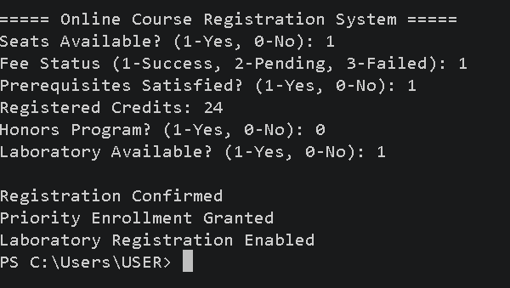
2)
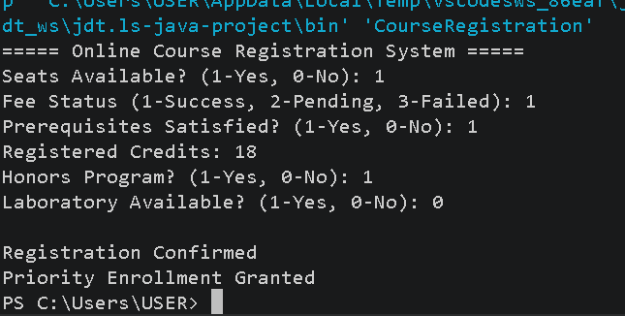
Negative output:
1)
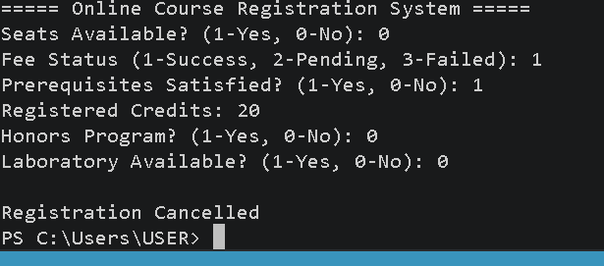
2)
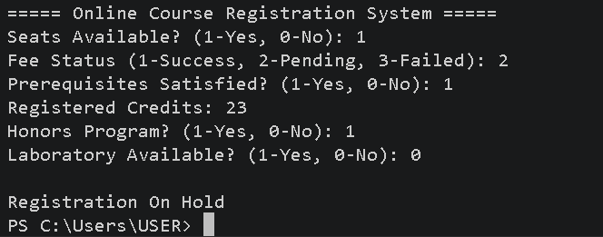
Design a testcase table:
Table 1:Decision Table
Conditions / Actions | Rule 1 | Rule 2 | Rule 3 | Rule 4 | Rule 5 | Rule 6
Seats Available | Y | Y | Y | N | Y | Y
Fee Successful | Y | N | N | - | Y | Y
Fee Pending | N | Y | N | - | N | N
Fee Failed | N | N | Y | - | N | N
Prerequisites Satisfied | Y | Y | Y | Y | N | Y
Credits > 20 | N | N | N | N | N | Y
Honors Program | Y | N | N | N | N | N
Laboratory Available | Y | Y | N | N | N | Y
Confirm Registration | ✔ | ✖ | ✖ | ✖ | ✖ | ✔
Priority Enrollment | ✔ | ✖ | ✖ | ✖ | ✖ | ✔
Laboratory Registration | ✔ | ✖ | ✖ | ✖ | ✖ | ✔
Registration On Hold | ✖ | ✔ | ✖ | ✖ | ✖ | ✖
Registration Cancelled | ✖ | ✖ | ✔ | ✔ | ✔ | ✖

Table 2: Decision Table Test Cases
TC ID | Seats | Fee | Eligibility | Credits | Honors | Lab | Expected Result
DT-01 | Yes | Success | Yes | 18 | Yes | Yes | Confirm + Priority + Lab
DT-02 | Yes | Pending | Yes | 22 | No | Yes | Registration On Hold
DT-03 | Yes | Failed | Yes | 18 | No | Yes | Registration Cancelled
DT-04 | No | Success | Yes | 21 | Yes | Yes | Registration Cancelled
DT-05 | Yes | Success | No | 18 | No | No | Registration Cancelled
DT-06 | Yes | Success | Yes | 24 | No | Yes | Confirm + Priority + Lab

Question 5:
A Scholarship Eligibility Management System is developed to automate the processing of student scholarship applications. The system contains a class named ScholarshipEligibility with the following business logic functions:
• CheckEligibility() – Determines whether a student is eligible for the scholarship based on cumulative GPA, annual family income, attendance percentage, number of arrears, and community service hours.
• CalculateScholarshipAmount() – Determines the scholarship amount to be awarded based on the student's GPA, family income category, and extracurricular achievement score.
• ValidateApplication() – Validates the application by checking the student's age, submission status of mandatory documents, and whether the application is submitted before the deadline.
Each function accepts multiple input parameters and performs different validation checks before returning the appropriate result. If any input violates the specified eligibility criteria or validation rules, the function returns an appropriate error message.
Task:
Using the Equivalence Class Testing technique
1. Identify the valid and invalid equivalence classes for every input parameter of each business
logic function.
2. Select suitable representative values for every equivalence class.
3. Design an optimized set of test cases by combining multiple input conditions so that all equivalence classes of all three business logic functions are covered with the minimum possible number of test cases.

Problem Statement
A Scholarship Eligibility Management System is developed to automate the processing of scholarship applications. The system contains three business logic functions:
- CheckEligibility() – Checks whether a student is eligible based on GPA, annual family income, attendance percentage, number of arrears, and community service hours.
- CalculateScholarshipAmount() – Calculates the scholarship amount using GPA, family income category, and extracurricular achievement score.
- ValidateApplication() – Validates the application using age, document submission status, and application submission before the deadline.
The application displays appropriate messages if any validation fails.

Algorithm
Step 1: Check Eligibility
- Read GPA, family income, attendance, arrears, and community service hours.
- If GPA ≥ 8.0, income ≤ ₹5,00,000, attendance ≥ 75%, arrears = 0, and service hours ≥ 20, declare the student Eligible.
- Otherwise, declare Not Eligible.
Step 2: Calculate Scholarship Amount
- Read GPA, income category, and extracurricular score.
- If GPA ≥ 9.0 and extracurricular score ≥ 80, award ₹50,000.
- Else if GPA ≥ 8.5, award ₹30,000.
- Else if GPA ≥ 8.0, award ₹15,000.
- Otherwise, no scholarship.
Step 3: Validate Application
- Read age, document status, and deadline status.
- If age is between 17 and 30, documents are submitted, and the application is submitted before the deadline, display Application Valid.
- Otherwise, display the corresponding validation error.
Code:
import java.util.Scanner;
public class ScholarshipEligibility {

public static void main(String[] args) {

Scanner sc = new Scanner(System.in);

System.out.println("===== Scholarship Eligibility System =====");

System.out.print("Enter GPA: ");
double gpa = sc.nextDouble();

System.out.print("Enter Annual Family Income: ");
double income = sc.nextDouble();

System.out.print("Enter Attendance (%): ");
double attendance = sc.nextDouble();

System.out.print("Enter Number of Arrears: ");
int arrears = sc.nextInt();

System.out.print("Enter Community Service Hours: ");
int service = sc.nextInt();

if (gpa >= 8.0 && income <= 500000 &&
attendance >= 75 &&
arrears == 0 &&
service >= 20) {

System.out.println("\nScholarship Eligibility : Eligible");

System.out.print("Enter Extracurricular Score: ");
int score = sc.nextInt();

if (gpa >= 9.0 && score >= 80)
System.out.println("Scholarship Amount : Rs.50000");
else if (gpa >= 8.5)
System.out.println("Scholarship Amount : Rs.30000");
else
System.out.println("Scholarship Amount : Rs.15000");

} else {
System.out.println("\nScholarship Eligibility : Not Eligible");
}

System.out.print("\nEnter Age: ");
int age = sc.nextInt();

System.out.print("Documents Submitted? (1-Yes,0-No): ");
int docs = sc.nextInt();

System.out.print("Submitted Before Deadline? (1-Yes,0-No): ");
int deadline = sc.nextInt();

if (age >= 17 && age <= 30 && docs == 1 && deadline == 1)
System.out.println("Application Status : Valid");
else
System.out.println("Application Status : Invalid");

sc.close();
}
}
Positive output:
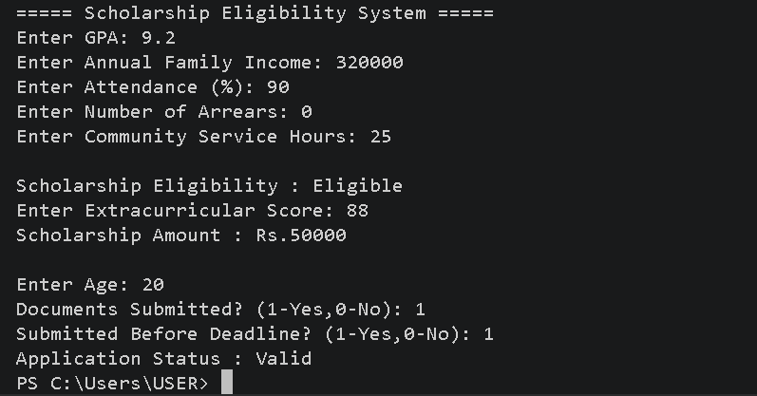
Negative output:
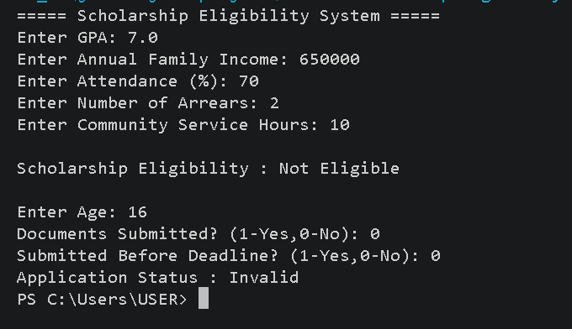
Design a testcase table:
Table 1: Equivalence Class Table – CheckEligibility()
Parameter | Valid Class | Invalid Class | Representative Values
GPA | 8.0 – 10.0 | < 8.0 | 9.2, 7.4
Family Income | ₹0 – ₹5,00,000 | > ₹5,00,000 | ₹3,20,000, ₹6,50,000
Attendance | 75% – 100% | < 75% | 90, 70
Arrears | 0 | > 0 | 0, 2
Service Hours | ≥ 20 | < 20 | 25, 15

Table 2: Equivalence Class Table – CalculateScholarshipAmount()
Parameter | Valid Class | Invalid Class | Representative Values
GPA | 8.0 – 10.0 | < 8.0 | 9.1, 7.3
Income Category | Low / Medium / High | Invalid | Low, Premium
Activity Score | 0 – 100 | < 0 or > 100 | 88, -5, 120

Table 3: Equivalence Class Table – ValidateApplication()
Parameter | Valid Class | Invalid Class | Representative Values
Age | 17 – 30 | <17 or >30 | 20, 15, 35
Documents | Submitted | Not Submitted | Yes, No
Deadline | Before Deadline | After Deadline | Yes, No

Table 4: Optimized Equivalence Class Test Cases
TC ID | GPA | Income | Attendance | Arrears | Service | Score | Age | Docs | Deadline | Expected Result
EC-01 | 9.2 | 3,20,000 | 90 | 0 | 25 | 88 | 20 | Yes | Yes | Eligible, ₹50,000, Valid
EC-02 | 8.6 | 4,50,000 | 80 | 0 | 22 | 70 | 22 | Yes | Yes | Eligible, ₹30,000
EC-03 | 8.1 | 2,80,000 | 78 | 0 | 20 | 65 | 24 | Yes | Yes | Eligible, ₹15,000
EC-04 | 7.5 | 3,00,000 | 85 | 0 | 25 | 90 | 21 | Yes | Yes | GPA Invalid
EC-05 | 8.8 | 6,20,000 | 90 | 0 | 25 | 80 | 20 | Yes | Yes | Income Invalid
EC-06 | 8.9 | 3,20,000 | 70 | 0 | 25 | 85 | 20 | Yes | Yes | Attendance Invalid
EC-07 | 8.7 | 3,20,000 | 90 | 2 | 25 | 85 | 20 | Yes | Yes | Arrears Present
EC-08 | 8.8 | 3,20,000 | 90 | 0 | 15 | 85 | 20 | Yes | Yes | Service Hours Invalid
EC-09 | 8.9 | 3,20,000 | 90 | 0 | 25 | 85 | 15 | No | No | Application Invalid

Question 6:
An Online Banking Loan Processing System is developed to evaluate and process customer loan applications. The system contains a class named LoanProcessor with the following business logic functions:
• validateApplicant() – Validates the applicant's age, annual income, employment experience, credit score, and existing loan amount.
• calculateEligibleLoanAmount() – Determines the maximum loan amount based on annual income, credit score, debt-to-income ratio, and employment type.
• calculateInterestRate() – Determines the applicable interest rate based on credit score, loan amount, repayment tenure, and customer category. Each function validates multiple input parameters and applies different business rules before returning the appropriate result.
Task:
Using the Equivalence Class Testing technique:
1. Identify valid and invalid equivalence classes for every input parameter.
2. Select representative values for each equivalence class.
3. Design an optimized set of test cases by combining multiple input conditions so that all equivalence classes across the three business logic functions are covered with the minimum possible number of test cases.

Problem Statement
An Online Banking Loan Processing System is developed to evaluate and process customer loan applications. The system contains three business logic functions:
- validateApplicant() – Validates the applicant based on age, annual income, employment experience, credit score, and existing loan amount.
- calculateEligibleLoanAmount() – Determines the maximum eligible loan amount using annual income, credit score, debt-to-income ratio, and employment type.
- calculateInterestRate() – Calculates the applicable interest rate based on credit score, loan amount, repayment tenure, and customer category.
The application validates all inputs and displays appropriate messages if any input violates the specified business rules.

Algorithm
Step 1: Validate Applicant
- Read applicant age, annual income, employment experience, credit score, and existing loan amount.
- If age is between 21–60, income ≥ ₹3,00,000, experience ≥ 2 years, credit score ≥ 700, and existing loan ≤ ₹5,00,000, declare the applicant Eligible.
- Otherwise, display Applicant Not Eligible.
Step 2: Calculate Eligible Loan Amount
- Read debt-to-income ratio and employment type.
- If eligible:
  - Credit Score ≥ 800 → ₹20,00,000
  - Credit Score 750–799 → ₹15,00,000
  - Credit Score 700–749 → ₹10,00,000
- Display the eligible loan amount.
Step 3: Calculate Interest Rate
- Read loan amount, repayment tenure, and customer category.
- If Premium customer and credit score ≥ 800 → 7% interest.
- Else if credit score ≥ 750 → 8%.
- Otherwise → 10%.
- Display the applicable interest rate.
Code:
import java.util.Scanner;

public class LoanProcessor {

public static void main(String[] args) {

Scanner sc = new Scanner(System.in);

System.out.println("===== Online Banking Loan Processing System =====");

System.out.print("Enter Age: ");
int age = sc.nextInt();

System.out.print("Enter Annual Income: ");
double income = sc.nextDouble();

System.out.print("Employment Experience (Years): ");
int experience = sc.nextInt();

System.out.print("Credit Score: ");
int creditScore = sc.nextInt();

System.out.print("Existing Loan Amount: ");
double existingLoan = sc.nextDouble();

if (age >= 21 && age <= 60 &&
income >= 300000 &&
experience >= 2 &&
creditScore >= 700 &&
existingLoan <= 500000) {

System.out.println("\nApplicant Status : Eligible");

System.out.print("Debt-to-Income Ratio (%): ");
double dti = sc.nextDouble();

System.out.print("Employment Type (Permanent/Contract): ");
String emp = sc.next();

if (creditScore >= 800)
System.out.println("Eligible Loan Amount : Rs.20,00,000");
else if (creditScore >= 750)
System.out.println("Eligible Loan Amount : Rs.15,00,000");
else
System.out.println("Eligible Loan Amount : Rs.10,00,000");

System.out.print("Loan Amount Requested: ");
double loan = sc.nextDouble();

System.out.print("Repayment Tenure (Years): ");
int tenure = sc.nextInt();

System.out.print("Customer Category (Premium/Regular): ");
String category = sc.next();

if (category.equalsIgnoreCase("Premium") && creditScore >= 800)
System.out.println("Interest Rate : 7%");
else if (creditScore >= 750)
System.out.println("Interest Rate : 8%");
else
System.out.println("Interest Rate : 10%");

} else {
System.out.println("\nApplicant Status : Not Eligible");
}

sc.close();
}
}
Positive output:
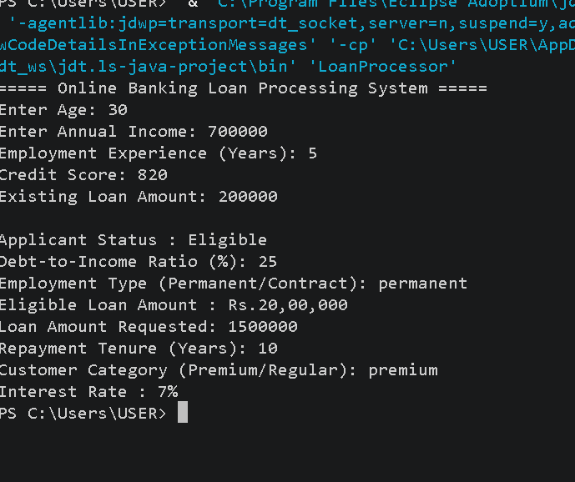
Negative output:
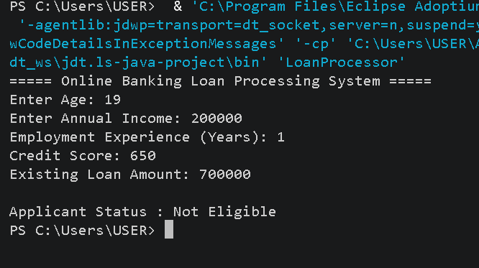
Design a testcase table:
Table 1: Equivalence Class Table – validateApplicant()
Parameter | Valid Class | Invalid Class | Representative Value
Age | 21–60 | <21 or >60 | 30, 18, 65
Annual Income | ≥ ₹3,00,000 | < ₹3,00,000 | ₹7,00,000, ₹2,50,000
Experience | ≥ 2 years | < 2 years | 5, 1
Credit Score | 700–900 | <700 | 820, 650
Existing Loan | ≤ ₹5,00,000 | > ₹5,00,000 | ₹2,00,000, ₹6,50,000

Table 2: Equivalence Class Table – calculateEligibleLoanAmount()
Parameter | Valid Class | Invalid Class | Representative Value
Annual Income | ≥ ₹3,00,000 | < ₹3,00,000 | ₹6,50,000, ₹2,50,000
Credit Score | 700–900 | <700 | 780, 650
Debt-to-Income Ratio | 0–40% | >40% | 25%, 55%
Employment Type | Permanent / Contract | Invalid Type | Permanent, Temporary

Table 3: Equivalence Class Table – calculateInterestRate()
Parameter | Valid Class | Invalid Class | Representative Value
Credit Score | 700–900 | <700 | 810, 650
Loan Amount | ₹1 – ₹20,00,000 | ≤0 | ₹12,00,000, ₹0
Repayment Tenure | 1–30 Years | ≤0 | 10, 0
Customer Category | Premium / Regular | Invalid | Premium, Gold

Table 4: Optimized Equivalence Class Test Cases
TC ID | Age | Income | Experience | Credit Score | Existing Loan | DTI Ratio | Employment Type | Loan Amount | Tenure | Customer Category | Expected Result
EC-01 | 35 | ₹9,00,000 | 6 | 780 | ₹3,00,000 | 30% | Salaried | ₹12,00,000 | 15 | Premium | Loan Approved
EC-02 | 20 | ₹9,00,000 | 6 | 780 | ₹3,00,000 | 30% | Salaried | ₹12,00,000 | 15 | Premium | Invalid Age
EC-03 | 35 | ₹2,50,000 | 6 | 780 | ₹3,00,000 | 30% | Salaried | ₹12,00,000 | 15 | Premium | Income Not Eligible
EC-04 | 35 | ₹9,00,000 | 1 | 780 | ₹3,00,000 | 30% | Salaried | ₹12,00,000 | 15 | Premium | Insufficient Experience
EC-05 | 35 | ₹9,00,000 | 6 | 620 | ₹3,00,000 | 30% | Salaried | ₹12,00,000 | 15 | Premium | Poor Credit Score
EC-06 | 35 | ₹9,00,000 | 6 | 780 | ₹11,50,000 | 30% | Salaried | ₹12,00,000 | 15 | Premium | Existing Loan Exceeded
EC-07 | 35 | ₹9,00,000 | 6 | 780 | ₹3,00,000 | 45% | Salaried | ₹12,00,000 | 15 | Premium | High Debt-to-Income Ratio
EC-08 | 35 | ₹9,00,000 | 6 | 780 | ₹3,00,000 | 30% | Unemployed | ₹12,00,000 | 15 | Premium | Invalid Employment Type
EC-09 | 35 | ₹9,00,000 | 6 | 780 | ₹3,00,000 | 30% | Salaried | ₹55,00,000 | 15 | Premium | Loan Amount Out of Range

